Appendix 6: SWIFT Quantitative Information Sheet and Consent Form: Participants
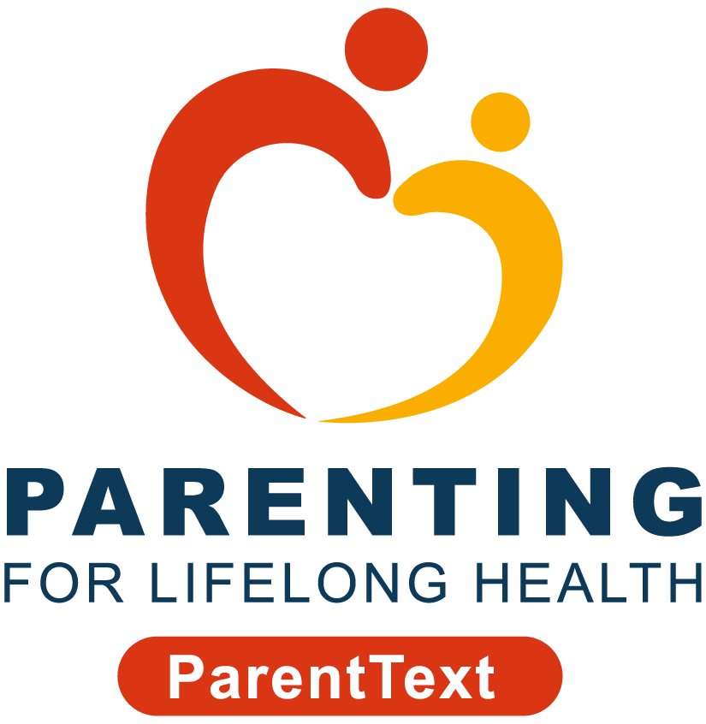



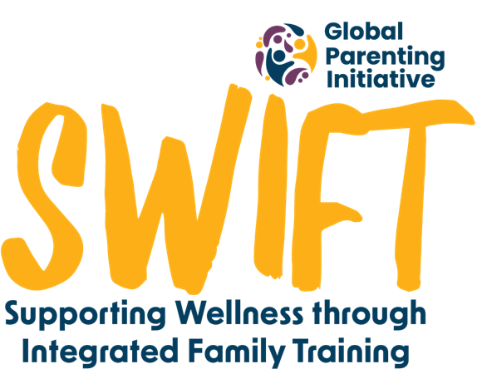
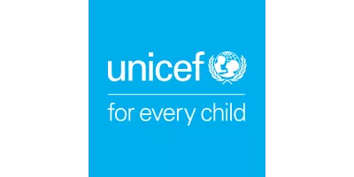

You’re invited to join a study carried out by researchers from the University of Cape Town in South Africa and the University of Oxford in the United Kingdom.
We’re doing this study to learn about your experience with chatbots developed by Parenting for Lifelong Health (PLH), Clowns Without Borders South Africa (CWBSA), IDEMS International, and UNICEF South Africa.
Before you decide if you’d like to join, it’s important for you to know why we’re doing this research and what it involves. You can read through this Participant Information Sheet.
If you have any questions about the chatbot or the study before you agree to participate, please email the study team at swift@globalparenting.org, or message us on WhatsApp at +27 XX XXX XXXX. We’re here to help you!
Who can join?
To be part of the study, you need to be 18 years or older, be the parent or caregiver of a child between the ages of 2 and 17 years and live in the Western Cape province of South Africa. You also need to agree to take part in the study.
Do I have to join?
No, it's up to you if you want to join or not. If you don't want to participate, there will be no implications for you and your family - you will still get clinic services as usual. If you do choose to join the study, but don't want to answer some of the questions, you can stop and leave the study at any time. You can still access the chatbot programme if you don’t want to participate in the study and answer the questions. If you want to stop getting messages, you can type "STOP MESSAGES".
What happens if I join?
If you decide to join, you will need to read the consent form below and answer “Yes” on WhatsApp to the question, “I have read and understand the information, and I give consent to participate in the study”.
The study team will then send you a survey through WhatsApp with about 35 questions. The survey asks you about your life and about one child you take care of. If you have more than one child, you’ll be asked to pick the child you find most challenging.
We’ll send you a survey with similar questions again one month later, and then again after three months. You’ll also be asked if you want to do a phone or in-person interview with one of our researchers.
Please note that before you answer any questions or talk to someone from our team, try to make sure you're in a safe and private place. It could be your room or somewhere quiet where no one else can see your answers. This will help keep your information private and make sure you feel comfortable when you're answering questions.
After completing the first survey, you’ll start to get messages from the ParentText chatbot.
The ParentText chatbot is a 5-day course for parents and caregivers with 5 daily lessons on building a good relationship with your child.
Do I get anything for joining the study?
You’ll get R25 airtime for finishing the first survey, R50 airtime for finishing the second survey, and R75 for finishing the last survey. If you’re chosen for an interview with someone from our team, you’ll get a R120 Shoprite voucher.
What happens to my information if I join?
If you agree to participate in the study, we only collect what’s needed for the study and make sure that we store it safely and securely. Your information, including the answers you give during the surveys, and any information you provide via email or WhatsApp, will be kept safe on secure servers at the University of Cape Town.
In addition to your responses to the survey questions, we will request you to provide your name and cell phone number for research purposes, as well as your and your child’s gender identification, and your child’s name (optional). Any details that identify you will be kept separate, and only authorised staff can access them. The data will be collected through the chatbot and stored securely on servers to be accessed only by the research team. All data will be kept for five years after the study, but any personal information will be deleted as soon as the study ends. Ethics committees may also check the information.
You have the right to request access to your data, to correct any mistakes in your data, and to request us to delete it or transfer it somewhere else. Please email the study team before [*date to be determined] if you would like to do any of these.
Your information will stay private unless the law says otherwise. If you tell us that your child has been abused, we will have to report that to the authorities. However, we will support you through this process. After the study, we may share the information with other researchers but without any of your personal details, so no-one will be able to see who you are. You also have the right to see, correct, or ask us to delete your personal information. If you don’t agree to participate, please note that minimal user data is captured. This would only be used in the study to understand how many people showed interest in the programme. If you don't want your information to be used in this way, please email the study team.
What happens to the research results?
The information you share with us will help us understand how to support families like yours in South Africa. We plan to share the results of the study in academic journals, policy briefs and conferences so others can learn from this study too.
Who are some of the study team members?
The principal investigators of this study are Professor Cathy Ward and Cindee Bruyns, and Carly Katzef is a co-investigator. They are all based at the University of Cape Town.
Are there any risks in joining this study?
We don’t expect any risks to you if you join this study. If any questions make you uncomfortable, you don’t have to answer them.
If you become upset when using the programme, you can type “HELP” at any time to receive additional support. Remember, you can stop participating anytime, without giving a reason.
Who pays for the study?
This study is part of the Global Parenting Initiative, which is funded by the LEGO Foundation, Oak Foundation, the World Childhood Foundation, The Human Safety Net, and the UK Research and Innovation Global Challenges Research Fund.
Data protection
The Universities of Cape Town and Oxford make sure your personal information is used safely and correctly, just for research. The study follows data protection laws like GDPR (General Data Protection Regulation) in the UK and POPIA (Protection of Personal Information Act) in South Africa. Any data that is transferred across borders will comply with POPIA.
Who has approved this study?
[Once the ethics has been approved this will read as follows: This study has received approval from the University of Cape Town’s Centre for Social Science Research Ethics Committee and Faculty of Health Sciences Human Research Ethics Committee. The study has also been approved by the Western Cape Department of Health and Wellness and Department of Social Development, and City of Cape Town’s City health.]
Who do I contact if I have questions or concerns?
If you have any questions or concerns about your rights as a study participant, you can contact the study team at swift@globalparenting.org or on WhatsApp at +27 XX XXX XXXX (messages only).
If you have more questions or concerns about your rights, you can contact this ethics committees:

Name | Telephone | Email
University of Cape Town Centre for Social Science Research | +27 21 650 4656 | cssr@uct.ac.za
Human Research Ethics Committee |  | hrec-enquiries@uct.ac.za

Informed Consent to Take Part in the Study
Please read these statements carefully:
- I have read the information above and know what I need to do.
- I had time to think about the information and ask questions. I got satisfying answers if I did ask questions.
- I know I can say yes or no to being in the study. If I say yes, I can stop any time before the [*date to still be determined], without saying why, and there will be no implications for me and my family.
- I know who can see my information, how it will be kept safe, and what happens to it after the study.
- I know I can request access to my data, correct any mistakes, ask to delete it, or for it to be transferred somewhere else.
- I know I won’t be named in any papers or reports from this study.
- I know who to contact if I have a problem with the study.
- You can contact me again if more information is needed from me.
- You can keep my contact information safe so you can tell me about the results of the study.
If you have read and understand the above document, agree with the messages and give consent to participate in the study, press “Yes” in WhatsApp. Type "EXIT" in WhatsApp if you do not want to participate.

